**ethers.js Provider类**

**连接ALCHEMY节点**

|  |
| --- |
| Solidity import { ethers } from "ethers"; const ALCHEMY_ID = '4x_BEqF-tXW3ZE8cduzf2VfvRaWxrNkW'  const providerGoerli=new ethers.providers.JsonRpcProvider(`https://eth-goerli.g.alchemy.com/v2/${ALCHEMY_ID}`); |

**利用Provider读取链上数据**

**1. 查询vitalik在Goerli测试网的ETH余额**

|  |
| --- |
| Solidity console.log("1. 查询vitalik在Goerli测试网的ETH余额");  const balanceGoerli = await providerGoerli.getBalance(vitalik.eth);  // *输出Goerli测试网ETH余额*  console.log(Goerli ETH Balance of vitalik: ${ethers.utils.formatEther(balanceGoerli)} ETH); |

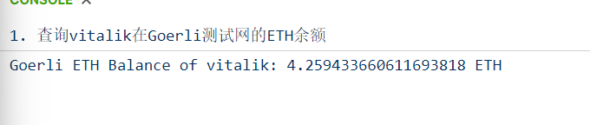

**2.查询provider连接到了哪条链**

|  |
| --- |
| Solidity  console.log("\n2. 查询provider连接到了哪条链") const network = await provider.getNetwork(); console.log(network); |

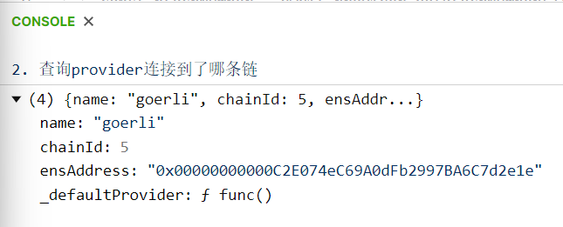

**3.查询区块高度**

|  |
| --- |
| Solidity console.log("\n3. 查询区块高度")  const blockNumber = await provider.getBlockNumber();  console.log(blockNumber); |

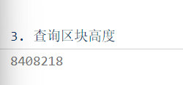

**4.查询当前gas price**

|  |
| --- |
| Solidity console.log("\n4. 查询当前gas price") const gasPrice = await provider.getGasPrice(); console.log(gasPrice); |

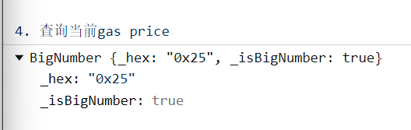

**5.查询当前建议的gas设置**

|  |
| --- |
| Solidity  console.log("\n5. 查询当前建议的gas设置")  const feeData = await provider.getFeeData();  console.log(feeData); |

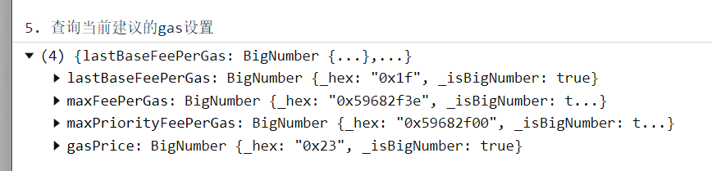

**6.查询区块信息**

|  |
| --- |
| Solidity  console.log("\n6. 查询区块信息")  const block = await provider.getBlock(0);  console.log(block); |

